**Practical Number: 1 (Task 2 and 3)**

**Course Name: DBMS**

**Student Name: Sharvayu Zade**

**Batch: 2023-27**

**PRN Number: 23070521135**

**Semester: 4th**

**Section: B**

**Batch: B2**

**Session: 2024-25**

Task 2 ER Diagram:

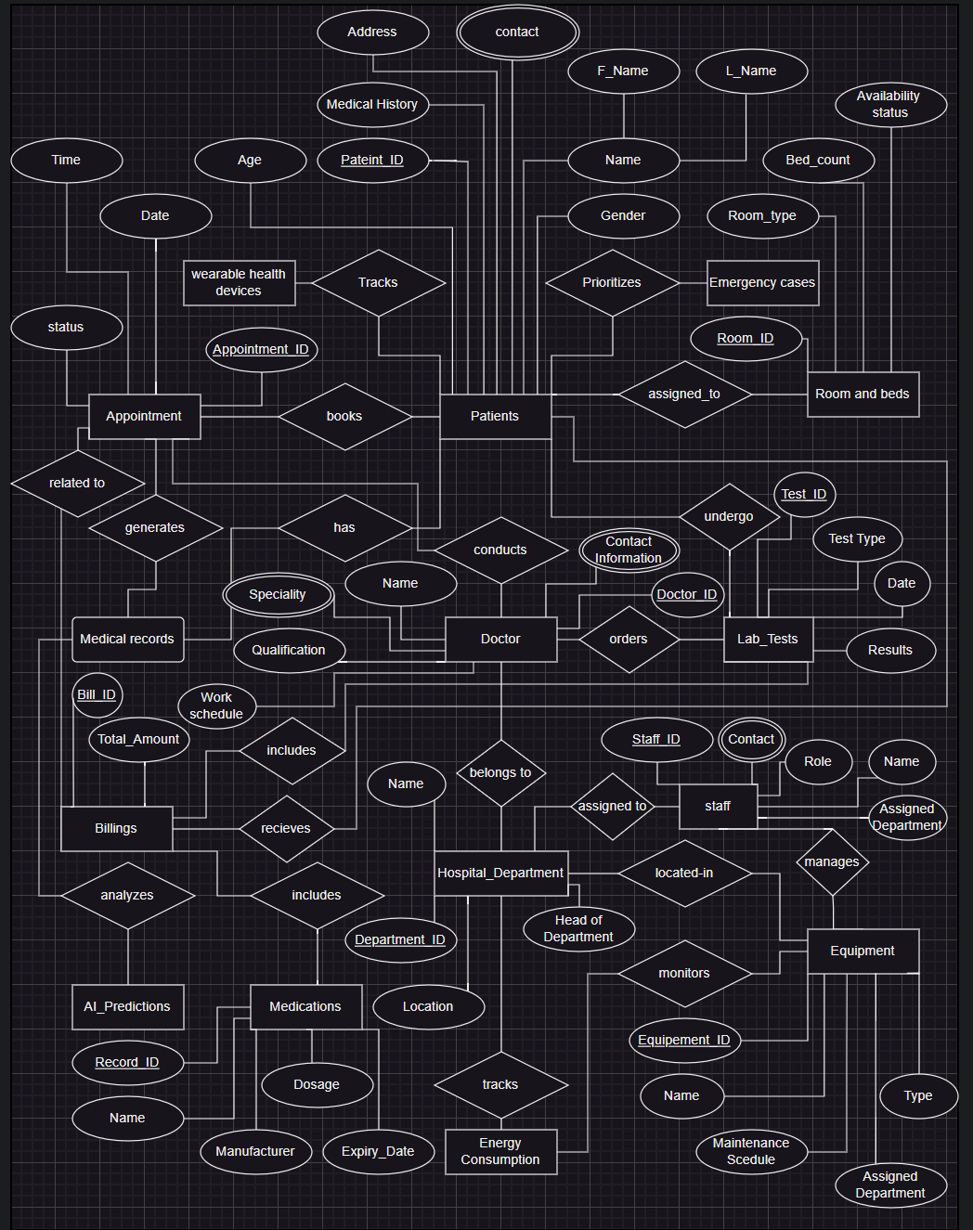

### ****Tables:****

### ****1. Patients****

| **Column Name** | **Data Type** | **Key** | **Description** |
| --- | --- | --- | --- |
| PatientID | INT | Primary Key | Unique identifier for patients. |
| Name | VARCHAR(100) |  | Patient's full name. |
| Age | INT |  | Patient's age. |
| Gender | CHAR(1) |  | Patient's gender (M/F). |
| ContactInfo | VARCHAR(100) |  | Patient's contact details. |
| Address | VARCHAR(200) |  | Patient's residential address. |
| MedicalHistory | TEXT |  | Details of patient's medical history. |

### ****2. Doctors****

| **Column Name** | **Data Type** | **Key** | **Description** |
| --- | --- | --- | --- |
| DoctorID | INT | Primary Key | Unique identifier for doctors. |
| Name | VARCHAR(100) |  | Doctor's full name. |
| Specialty | VARCHAR(50) |  | Doctor's area of expertise. |
| Qualification | VARCHAR(50) |  | Doctor's qualifications. |
| ContactInfo | VARCHAR(100) |  | Doctor's contact details. |
| WorkSchedule | TEXT |  | Doctor's schedule information. |
| DepartmentID | INT | Foreign Key | References hospital department. |

### ****3. Appointments****

| **Column Name** | **Data Type** | **Key** | **Description** |
| --- | --- | --- | --- |
| AppointmentID | INT | Primary Key | Unique identifier for appointments. |
| PatientID | INT | Foreign Key | References the patient. |
| DoctorID | INT | Foreign Key | References the doctor. |
| Date | DATE |  | Appointment date. |
| Time | TIME |  | Appointment time. |
| ReasonForVisit | TEXT |  | Reason for the appointment. |
| Status | VARCHAR(20) |  | Status (Scheduled, Completed). |

### ****4. Medical Records****

| **Column Name** | **Data Type** | **Key** | **Description** |
| --- | --- | --- | --- |
| RecordID | INT | Primary Key | Unique identifier for records. |
| PatientID | INT | Foreign Key | References the patient. |
| DoctorID | INT | Foreign Key | References the doctor. |
| DateOfRecord | DATE |  | Date of the medical record. |
| Diagnosis | TEXT |  | Patient's diagnosis. |
| PrescribedMedication | TEXT |  | Medications prescribed. |

### ****5. Medications****

| **Column Name** | **Data Type** | **Key** | **Description** |
| --- | --- | --- | --- |
| MedicationID | INT | Primary Key | Unique identifier for medications. |
| Name | VARCHAR(100) |  | Medication name. |
| Manufacturer | VARCHAR(100) |  | Manufacturer's name. |
| Dosage | VARCHAR(50) |  | Medication dosage. |
| ExpiryDate | DATE |  | Medication expiry date. |

### ****6. Hospital Departments****

| **Column Name** | **Data Type** | **Key** | **Description** |
| --- | --- | --- | --- |
| DepartmentID | INT | Primary Key | Unique identifier for departments. |
| Name | VARCHAR(100) |  | Department name. |
| Location | VARCHAR(100) |  | Location within the hospital. |
| HeadOfDepartment | VARCHAR(100) |  | Head of the department. |

### ****7. Staff****

| **Column Name** | **Data Type** | **Key** | **Description** |
| --- | --- | --- | --- |
| StaffID | INT | Primary Key | Unique identifier for staff. |
| Name | VARCHAR(100) |  | Staff member's name. |
| Role | VARCHAR(50) |  | Staff role (e.g., Nurse). |
| ContactInfo | VARCHAR(100) |  | Staff contact details. |
| AssignedDepartment | INT | Foreign Key | References the department. |

### ****8. Lab Tests****

| **Column Name** | **Data Type** | **Key** | **Description** |
| --- | --- | --- | --- |
| TestID | INT | Primary Key | Unique identifier for lab tests. |
| PatientID | INT | Foreign Key | References the patient. |
| DoctorID | INT | Foreign Key | References the doctor who ordered the test. |
| TestType | VARCHAR(100) |  | Type of lab test conducted. |
| Date | DATE |  | Date of the lab test. |
| Results | TEXT |  | Results of the lab test. |

### ****9. Rooms and Beds****

| **Column Name** | **Data Type** | **Key** | **Description** |
| --- | --- | --- | --- |
| RoomID | INT | Primary Key | Unique identifier for rooms. |
| RoomType | VARCHAR(50) |  | Type of room (e.g., ICU, General). |
| BedCount | INT |  | Number of beds in the room. |
| AvailabilityStatus | VARCHAR(20) |  | Status (Available/Occupied). |

### ****10. Billing****

| **Column Name** | **Data Type** | **Key** | **Description** |
| --- | --- | --- | --- |
| BillID | INT | Primary Key | Unique identifier for billing. |
| PatientID | INT | Foreign Key | References the patient. |
| AppointmentID | INT | Foreign Key | References the appointment. |
| TotalAmount | DECIMAL(10, 2) |  | Total amount of the bill. |
| PaymentStatus | VARCHAR(20) |  | Payment status (Paid/Unpaid). |

### ****11. Equipment****

| **Column Name** | **Data Type** | **Key** | **Description** |
| --- | --- | --- | --- |
| EquipmentID | INT | Primary Key | Unique identifier for equipment. |
| Name | VARCHAR(100) |  | Equipment name. |
| Type | VARCHAR(50) |  | Type of equipment. |
| AssignedDepartment | INT | Foreign Key | References the department. |
| MaintenanceSchedule | TEXT |  | Details of maintenance schedule. |

### ****12. Wearable Devices**** (Innovative)

| **Column Name** | **Data Type** | **Key** | **Description** |
| --- | --- | --- | --- |
| DeviceID | INT | Primary Key | Unique identifier for wearable devices. |
| PatientID | INT | Foreign Key | References the patient. |
| DeviceType | VARCHAR(50) |  | Type of device (e.g., Heart Monitor). |
| TrackedVitals | TEXT |  | Vitals tracked (e.g., Heart Rate, Temperature). |
| DataTimestamp | TIMESTAMP |  | Time of the recorded data. |

### ****13. Emergency Cases**** (Innovative)

| **Column Name** | **Data Type** | **Key** | **Description** |
| --- | --- | --- | --- |
| EmergencyID | INT | Primary Key | Unique identifier for emergency cases. |
| PatientID | INT | Foreign Key | References the patient. |
| PriorityLevel | VARCHAR(20) |  | Priority level of the emergency. |
| AllocatedResources | TEXT |  | Resources allocated for the case. |
| CaseDescription | TEXT |  | Description of the emergency case. |

### ****14. AI Predictions**** (Innovative)

| **Column Name** | **Data Type** | **Key** | **Description** |
| --- | --- | --- | --- |
| PredictionID | INT | Primary Key | Unique identifier for predictions. |
| PatientID | INT | Foreign Key | References the patient. |
| AnalysisDate | DATE |  | Date of the AI prediction. |
| Insights | TEXT |  | Insights generated by the AI. |

### ****15. Energy Consumption**** (Innovative)

| **Column Name** | **Data Type** | **Key** | **Description** |
| --- | --- | --- | --- |
| RecordID | INT | Primary Key | Unique identifier for energy consumption records. |
| DepartmentID | INT | Foreign Key | References the department. |
| EquipmentID | INT | Foreign Key | References the equipment. |
| ConsumptionDate | DATE |  | Date of energy consumption record. |
| EnergyConsumed | DECIMAL(10, 2) |  | Energy consumed (in kWh). |

Task 3 EER Diagram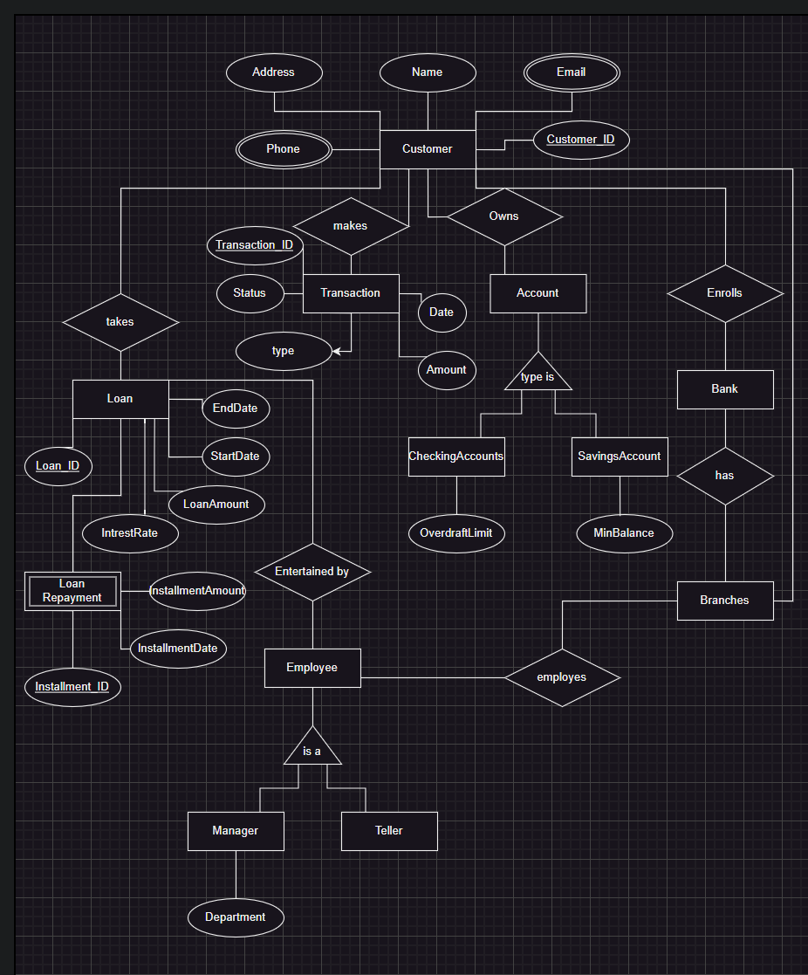

Tables:

#### **1. Customers**

| **Column Name** | **Data Type** | **Constraints** |
| --- | --- | --- |
| CustomerID | INT | Primary Key (PK) |
| Name | VARCHAR | NOT NULL |
| Address | TEXT |  |
| Phone | VARCHAR |  |
| Email | VARCHAR |  |

#### **2. Customer_AlternateContacts** (Multivalued attribute)

| **Column Name** | **Data Type** | **Constraints** |
| --- | --- | --- |
| CustomerID | INT | Foreign Key (FK -> Customers.CustomerID) |
| AlternateContactNumber | VARCHAR | NOT NULL |

#### **3. Accounts**

| **Column Name** | **Data Type** | **Constraints** |
| --- | --- | --- |
| AccountID | INT | Primary Key (PK) |
| CustomerID | INT | Foreign Key (FK -> Customers.CustomerID) |
| AccountType | ENUM | ('Savings', 'Checking') |
| Balance | DECIMAL |  |
| InterestRate | FLOAT |  |

#### **4. SavingsAccounts** (Specialization of Accounts)

| **Column Name** | **Data Type** | **Constraints** |
| --- | --- | --- |
| AccountID | INT | Primary Key (PK, FK -> Accounts.AccountID) |
| MinBalance | DECIMAL |  |

#### **5. CheckingAccounts** (Specialization of Accounts)

| **Column Name** | **Data Type** | **Constraints** |
| --- | --- | --- |
| AccountID | INT | Primary Key (PK, FK -> Accounts.AccountID) |
| OverdraftLimit | DECIMAL |  |

#### **6. Transactions**

| **Column Name** | **Data Type** | **Constraints** |
| --- | --- | --- |
| TransactionID | INT | Primary Key (PK) |
| AccountID | INT | Foreign Key (FK -> Accounts.AccountID) |
| Date | DATE |  |
| Amount | DECIMAL |  |
| Type | ENUM | ('Deposit', 'Withdrawal', 'Transfer') |

#### **7. Loans**

| **Column Name** | **Data Type** | **Constraints** |
| --- | --- | --- |
| LoanID | INT | Primary Key (PK) |
| CustomerID | INT | Foreign Key (FK -> Customers.CustomerID) |
| LoanAmount | DECIMAL |  |
| InterestRate | FLOAT |  |
| StartDate | DATE |  |
| EndDate | DATE |  |
| Status | VARCHAR |  |

#### **8. LoanRepayment** (Weak Entity Dependent on Loans)

| **Column Name** | **Data Type** | **Constraints** |
| --- | --- | --- |
| InstallmentID | INT | Primary Key (PK) |
| LoanID | INT | Foreign Key (FK -> Loans.LoanID) |
| InstallmentDate | DATE |  |
| InstallmentAmount | DECIMAL |  |

#### **9. Employees**

| **Column Name** | **Data Type** | **Constraints** |
| --- | --- | --- |
| EmployeeID | INT | Primary Key (PK) |
| Name | VARCHAR |  |
| Role | ENUM | ('Manager', 'Teller') |
| AssignedBranch | INT | Foreign Key (FK -> Branches.BranchID) |

#### **10. Managers** (Specialization of Employees)

| **Column Name** | **Data Type** | **Constraints** |
| --- | --- | --- |
| EmployeeID | INT | Primary Key (PK, FK -> Employees.EmployeeID) |
| Department | VARCHAR |  |

#### **11. Tellers** (Specialization of Employees)

| **Column Name** | **Data Type** | **Constraints** |
| --- | --- | --- |
| EmployeeID | INT | Primary Key (PK, FK -> Employees.EmployeeID) |

#### **12. Branches**

| **Column Name** | **Data Type** | **Constraints** |
| --- | --- | --- |
| BranchID | INT | Primary Key (PK) |
| Location | VARCHAR |  |
| PhoneNumber | VARCHAR |  |